Buffalo Point Elementary
“Home of the Stampede”
*Best Effort *Positive Attitude * Encourage Others
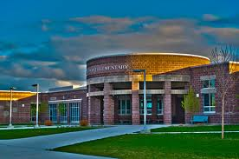
Community Council Members
Jonathan Whitesides |  | Mark Hyatt |  | Ashley Head
Graham Mearns |  | Kristy Nelson |  | Monica Bennion
Stacy Warner |  | Jessica Himle |  | Erin Anderson
Teresa Smith |  | Britney Thompson |  | Alli Behunin
Nancy Glauser | E | Juleeann Rivera |  | Erin Baum
Nate Tooley |  | Mariah Robins
Agenda for: Thursday, Oct. 5, 2017 in BPE Conference Room
- Welcome/Introductions

- Review minutes from last meeting (approve)

- Presentation on Council Responsibilities

- Statewide Training Available

- School Improvement Plan/ Share Assessment results from 2016-17

Next Meeting: Thursday, November 2, 2017 in BPE Conference Room

