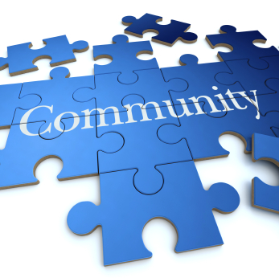
Buffalo Point Elementary Community Council
Wednesday, January 27 @ 3:45 in Library
- Community Council Members Review:

- Personalized Competency Based-Learning (PCBL): Devin Healey

- Next Community Council Meeting: February 24, 2021 @ 3:30 in the library

