Buffalo Point Elementary

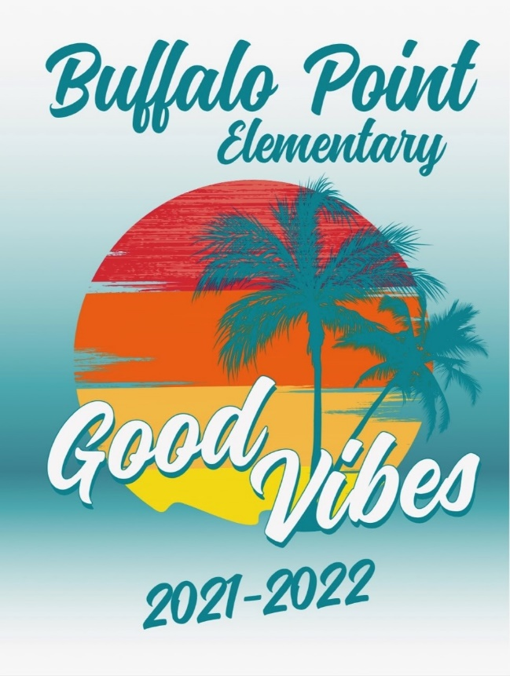

Student Handbook
2021-2022

1924 S. Doral Drive, Syracuse Utah, 84075
801-402-8400

Mr. Jake Heidrich-Principal
Mrs. Erika Muirbrook-Assistant Principal
Mrs. Andrea Scanlon-Office Manager
Mrs. Sherie Fenn- Facilities Manager

Buffalo Point Elementary Daily Schedule

Bell Schedule
Breakfast served | 8:25 A.M.
School Starts-First Bell | 8:45 A.M.
Tardy Bell Rings | 8:50 A.M.
School Ends Mon-Thurs | 3:25 P.M.
**School Ends Friday & Early Out | 1:25 P.M.
1st and 3rd Grade P.M. Recess | 1:45-2:00
2nd and 5th Grade P.M. Recess | 2:00-2:15
4th and 6th Grade P.M. Recess | 2:15-2:30

Lunch Schedule
Grade 1 | 11:00-11:40
Grade 2 | 11:15-11:55
Grade 3 | 11:30-12:10
Grade 4 | 12:00-12:40
Grade 5 | 12:15-12:55
Grade 6 | 12:30-1:10

Kindergarten Schedule:
Monday – Thursday AM Class: 8:45-11:30 PM Class: 12:45-3:25

Pre-School Schedule:
Monday & Wednesday: AM Class: 8:45-11:30 PM Class: 12:45-3:25
Tuesday & Thursday: AM Class: 8:45-11:30 PM Class: 12:45-3:25

Buffalo Point Elementary School
Principal: Mr. Jake Heidrich Assistant Principal: Mrs. Erika Muirbrook
Office Manager: Mrs. Andrea Scanlon Facilities Manager: Mrs. Sherie Fenn

My.DSD Guardian Account
It is important that you set up an online guardian account in order to access lunch payment options, schedule SEP conferences, view your child’s school progress and take surveys. Here’s how:
- Go to the school website www.davis.k12.ut.us/120
- Select the small my.DSD icon (little green leaf in the top right corner of any district web page).
- Login or set up a guardian account.
- To set up a guardian account, you will need to know your child’s student ID (ask your child or call the office) and pin number. If you do not know your child’s student pin number, follow the online steps to determine that pin number.
- Choose the “Student Information System” tab then: Tools (for appointment scheduler), Reports (for grades & test scores, attendance, Make Payment (for lunch options, lunch applications, fines) and more!

School Lunch/Breakfast
All Menus and nutrition information are on Nutrislice. http://davis.nutrislice.com/
Download the free Nutrislice app on your phone or tablet. Look for “School Lunch by Nutrislice” in the app store on your device. The link to apply for free or reduced-price school meals is: https://mydsd.davis.k12.ut.us/lunchapplication

Lunch:
- Student Free
- Reduced Free
- Adult $3.50

Breakfast:
- Student Free
- Reduced Free
- Adult $2.10

Lunch options now consist of five components of which your child will pick a minimum of 3. One of their choices MUST be a fruit or vegetable. The other choices are a milk, grain, or meat/meat alternative. Please emphasize with your child the importance of fruits and vegetables in a healthy diet. Because of COVID-19 and wearing masks as a personal choice/preference, at least two tables will be available in the lunchroom for those more sensitive to this issue.

Lunch Payment options
PLEASE SEND ADVANCE PAYMENT FOR MEALS!
- Online payments
- Cash, Checks, or Money Orders are only accepted at the school. Please clearly mark the payment with your student’s name and teacher. Payments may be turned into the lunchroom or the office.
- Free/Reduced Lunch Applications are available to fill out and submit online through your my.DSD guardian account. Paper forms are available in the school office.

POLICIES AND PROCEDURES

Attendance
WE EXPECT YOUR CHILD TO BE ON TIME-8:45 A.M.- EVERY DAY. Success in school is dependent upon good attendance. Buffalo Point Elementary School’s attendance procedure is to help parents and students with their responsibility for regular school attendance. The process of education requires continuity of instruction, class participation and study. Frequent absences and tardiness from classes disrupt the instructional process. Punctuality is critical for your child and for others in the classroom. Students who arrive late miss important instruction and disrupt the learning for fellow classmates. Late check-in begins at 8:50 A.M. in the office. We recognize that: illness; medical appointments; family emergencies; death of a family member or close friend; family activity or travel; approved school activity; or other instances identified by the school as reasonable are legitimate reasons for absence. If your child is absent, please notify the office or your child’s teacher as soon as possible. You will be alerted by the automated call-out system that your child was absent that day.

Checking Out
If your child must go home during the day, please come to the office to check him or her out. We will call your child to the office. For your student’s safety, your identification will be required at the time of check out.

Visiting Classrooms
Parents are always welcome! Please check-in at the office for a visitor badge. Please be aware that teachers appreciate appointments being made prior to such visits. Visiting school-age relatives and friends may not attend class with your children.

District Dress Code
Clean and appropriate clothing must be worn. “Grubbies”, bare feet, clothing which displays obscene or suggestive words or pictures, clothing or hair which is so extreme or odd that it may disrupt or interfere with school functions, will not be allowed. Shorts, if worn, must be the dress or walking type (just above the knee). Short shorts or miniskirts will not be allowed. No sleeveless shirts, bare midriffs, sagging pants, hats or gang attire. Flip-flops or shoes that make it difficult or unsafe for students at recess or in PE are not appropriate for school.

Managing Medication
If your child requires long term medication during the day, a form must be signed by you and your doctor. Medication is kept locked in the office and dispensed accordingly. Any short-term medications can be dispensed by parents bringing the medication to their child when needed.

Student Conduct and Discipline

student conduct and discipline policy

Safe Schools Expectations
For the safety of everyone in our school, the following expectations will be enforced:
- No real or pretend weapons
- No drugs, tobacco, or alcohol
- No fighting, harassment, discrimination, or bullying
- No disruptive behavior in a classroom or school activity. If your child chooses to go against any of these safe school expectations, he/she could be:
  - Suspended from school
  - Moved to another school
  - Expelled from school
  - Referred to the police

Bicycles & Scooters
A student can ride a bicycle, skateboard, or scooter to school when a parent has given permission and safety rules are followed. Bicycles, scooters, and skateboards are walked or carried (not ridden) on school property. If a student is found riding one of these vehicles on school property, the item will be confiscated and either released to parents any time or to students after three days. Bikes and scooters must be parked and locked in the bike rack during the day. We cannot assume responsibility for stolen or damaged equipment.

Electronic Devices/Toys
All electronic devices except for cell phones are to be left at home. All toys should be left at home. A toy is anything which interferes with learning (cars, stuffed animals, spinners, action figures, pretend weapons, etc.) Cell phone use is permitted only before and after school. Cell phones are to be turned off and left in backpacks during the day. Phones and other electronic devices used during school hours will be confiscated. Confiscated devices will only be released to parents. We cannot assume responsibility for lost, stolen or damaged electronic devices.

Student Use of School Telephones
Students should use the phone only in case of emergency and with special permission from their teacher. After school friend arrangements should be made at home. We discourage telephone messages from home except in an emergency.

Related Services
There are related services available at the school in Speech, Hearing, Psychological Testing, School Nurse, and Resource Teachers. If you feel your child needs any of these services, please contact the school.

Weather
Cold weather can be a problem. Please make sure that your children are dressed appropriately. Label all outerwear and help us eliminate the lost and found problem.

Staying after School
Teachers or staff members do not ask or require your child to stay after school for any reason unless you are contacted, and permission is given. Students are expected to go home immediately after school and/or wait for a parent or day care as directed by the guardian.

Animal Policy
The Health Code prohibits animals on school property with the exception for approved activities. Buffalo Point Elementary School’s policy states no pets for Show and Tell without prior approval.

Homework Policy

PTA Executive Board
Follow us on Facebook: Buffalo Point Elementary PTA or visit our website: buffalopoint.davis.k12.ut.us

President: Tristin Jensen: tristinjensen@gmail.com
President Elect: Tristin Jensen: tristinjensen@gmail.com
Treasurer: Krystal Nicholes: krys.nich13@yahoo.com
Secretary: Melanie Hawkes: mhawkes31@yahoo.com

