Buffalo Point Elementary
“Home of the Stampede”
*Best Effort *Positive Attitude * Encourage Others
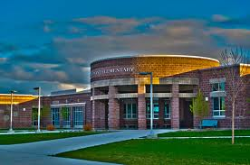
Community Council Members
Sue Bevan | x | Mark Hyatt | x | Ashley Head | E
Graham Mearns | A | Kristy Nelson | x | Monica Bennion | x
Stacy Warner | x | Jessica Himle | x | Erin Anderson | x
Jonathan Whitesides | x | Britney Thompson | x | Alli Behunin | x
Teresa Smith | x | Nancy Glauser | x
Notes for: Monday, August 28, 2017 in BPE Conference Room.
- Trust Lands Budget – BPE CC reviewed the trust lands budget and as of this date there is $94,000 in the fund. Several different committees will determine where to best use the money.
- Introductions of members – At the end of the school year las year, Erin Anderson was asked by Mr. Baird to join the committee. She will become the newest member and will serve through Oct. 1, 2019. Sue Bevan will be resigning as chairperson since she no longer has children attending BPE and Jonathan Whitesides, the Co-Chair, will be replacing her for the 2017-2018 school year.
- Candidates – 4 teachers have volunteered to serve another 2 years so we currently need 2-3 new candidates to serve as parents on the committee. Mrs. Nelson will give notice of these vacancies on the school website and applications will be accepted up until Sept. 5. After this the Community Council will determine if elections are needed due to the number of applications, and if so the elections will run Sept. 7-18. New members will be announced on the 19th of Sept.
- Next BPE CC meeting : Oct. 5, 2017

