Buffalo Point Elementary
“Home of the Stampede”
*Best Effort *Positive Attitude * Encourage Others
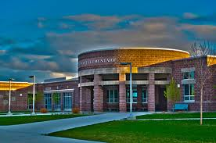
Community Council Members
Jonathan Whitesides |  | Mark Hyatt |  | Ashley Head
Graham Mearns |  | Kristy Nelson |  | Monica Bennion
Stacy Warner |  | Juleeann Rivera |  | Erin Anderson
Teresa Smith |  | Britney Thompson |  | Ali Behunin
Nancy Glauser |  | Mariah Robins |  | Erin Baum
Nate Tooley |  |  |  | Sophia Fleming (observing)
Agenda for: Thursday, Feb. 8, 2018 in BPE Conference Room.
- Approval of last month’s minutes:

- Nate Tooley will address us regarding money for subs for teachers for tier 2 tutoring

- Year Round School

- 3rd Grade donation from Economics Fair:

